P2: Guide for Annotation of Third Molars Project
In the dataset provided to you, you will find cropped images of panoramic radiographs featuring third molars and the mandibular canal. You are required to classify the images according to the classification provided below.
In the Excel file provided to you, five columns can be filled out for each image, with the first two being mandatory:
- In the first column (craniocaudal), write one of the following according to this classification system: Root Complex (RC) relation to canal.
  - Class 1 (Superior): Third molars are completely superior to the mandibular canal
  - Class 2 (Over-projecting): Third molars are between the borders of the mandibular canal
  - Class 3 (Inferior): At least some parts of the third molar are inferior to the canal (This might be the case in highly impacted teeth and teeth with horizontal orientation)

- In the second column (tooth position), you need to assess the part of the root crown complex (RC) in contact with the canal. Please note that it is only for the categories “2” and “3” that the tooth has close contact with the mandibular canal. Therefore, if the tooth is in category “1,” simply leave this cell empty.
  - Class A: The apical part of the RC is in contact with the mandibular canal
  - Class B: The middle part of the RC is in contact with the mandibular canal
  - Class C: The cervical (coronal) part of the RC is in contact with the mandibular canal (This might be the case in highly impacted teeth and teeth with horizontal orientation)

- In the third column (low quality), enter the number “1” for images deemed low quality, making it impossible to diagnose the category. If the quality is acceptable, simply leave this column blank.
- In the fourth column (root incomplete), assess whether the development of a tooth root and/or crown is not yet complete; if it is not complete, place the number “1” in the corresponding column. If it is complete, leave this column blank.
- In the fifth column (double-check needed), put 1 if you are uncertain about the category and you think it needs to be double-checked.
Please refer to the sample below as an example of how the classification works and how the completed Excel sheet should look.

Example for each craniocaudal class:
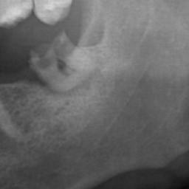  1: Superior | 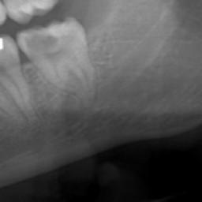  2: Over-projecting
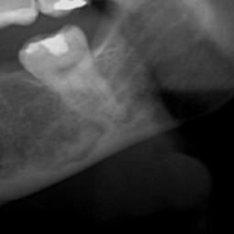
3: Inferior

c
Example for each tooth position class:

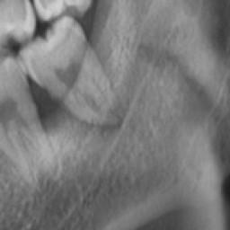  A: Apical | 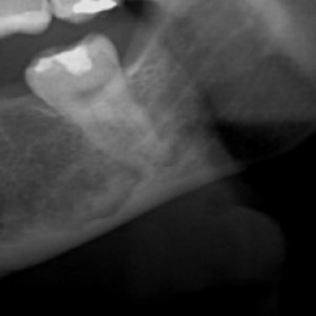  B: Middle
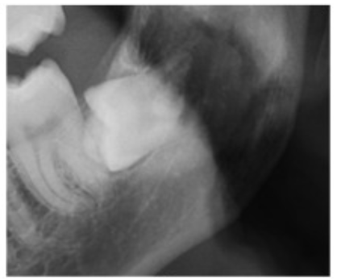
C: Cervical (Coronal)

Some examples of low-quality images:
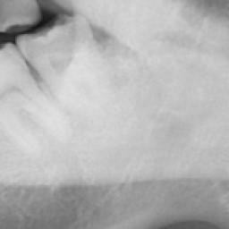

Example of an incomplete root:
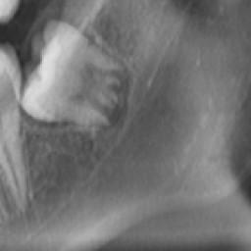

This is an example of how the table must look after completion:
Files | Craniocaudal (based on the guide above, you should put 1,2, or 3) | Tooth position (based on the guide above, you should put a, b, or c) | Low quality (put 1 if the image is low quality, otherwise leave it empty) | Root incompletion (put 1 if the tooth roots are not completely evolved, otherwise leave it empty) | Double-check needed  (Put 1 if you think it needs to be double-checked)
0001.png | 2 | A |  |  | 1
0002.png | 1 |  | 1
0003.png | 3 | B |  |  | 1
0004.png | 2 | C |  | 1
0005.png | 1

